DRAFT — owner review required. Do not distribute. Fill every [BRACKETED] field before release.

Scot Kinney — Founder Bio
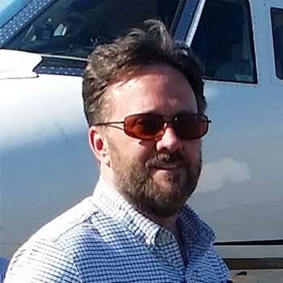
Short (≈50 words)
Scot Kinney is the founder of BotCom Inc., the company behind Bot Commander, a free AI command center that gives everyday people and small businesses a team of AI agents. A Minnesota entrepreneur with nearly 30 years of building internet services, virtual worlds and automation software, he previously founded AlterVerse, a Binance Labs Season 4 portfolio company.
Standard (≈150 words)
Scot Kinney is a lifelong entrepreneur and software architect based in Lake Shore, Minnesota, with nearly 30 years of experience building digital platforms, virtual worlds and business automation software.
He launched CityLink in 1996, an early regional internet service that provided dial-up access, web design and domain registration to more than 300 business clients. He went on to create AureusVR and the persistent online RPG BloodClans, then founded AlterVerse Inc., a metaverse and game-creation ecosystem he led as CEO from 2013 to 2024. AlterVerse was selected for Binance Labs' Season 4 portfolio in 2022, and its IP was sold to Unicorn Inc. in 2024.
Today Kinney is the founder of BotCom Inc. and lead architect of Bot Commander, a free, local-first AI command center for Windows, macOS and Linux, and builds character-driven Fortnite experiences under the Astra Worlds brand. He and his wife, Vicky, co-founded the My Neighbor to Love Coalition, a Minnesota non-profit working to end homelessness.
Quick facts
- Based in: Lake Shore, Minnesota
- Role: Founder, Bot Commander (botcom.ai); Astra Worlds (astraworlds.com)
- Previously: Founder & CEO, AlterVerse Inc. (2013–2024); Binance Labs Season 4 portfolio company (2022); AlterVerse IP sold to Unicorn Inc. (2024)
- Earlier: CityLink (1996); IT network administrator (1999–2004); AureusVR and BloodClans (2004–2013)
- Community: Co-founder and board member, My Neighbor to Love Coalition (mntlc.org)
- Contact: info@botcom.ai

