DRAFT — owner review required. Do not distribute. Fill every [BRACKETED] field before release.
FOR IMMEDIATE RELEASE

Bot Commander Launches Free AI Command Center That Puts a 16-Agent Team on Your Own Computer, With No Subscription and No Lock-In to One AI Company
While Big Tech rents single AI agents for up to $100 a month, Bot Commander gives everyday people and small businesses a voice-driven AI team that they own, customize, and control, free for Windows, macOS, and Linux.
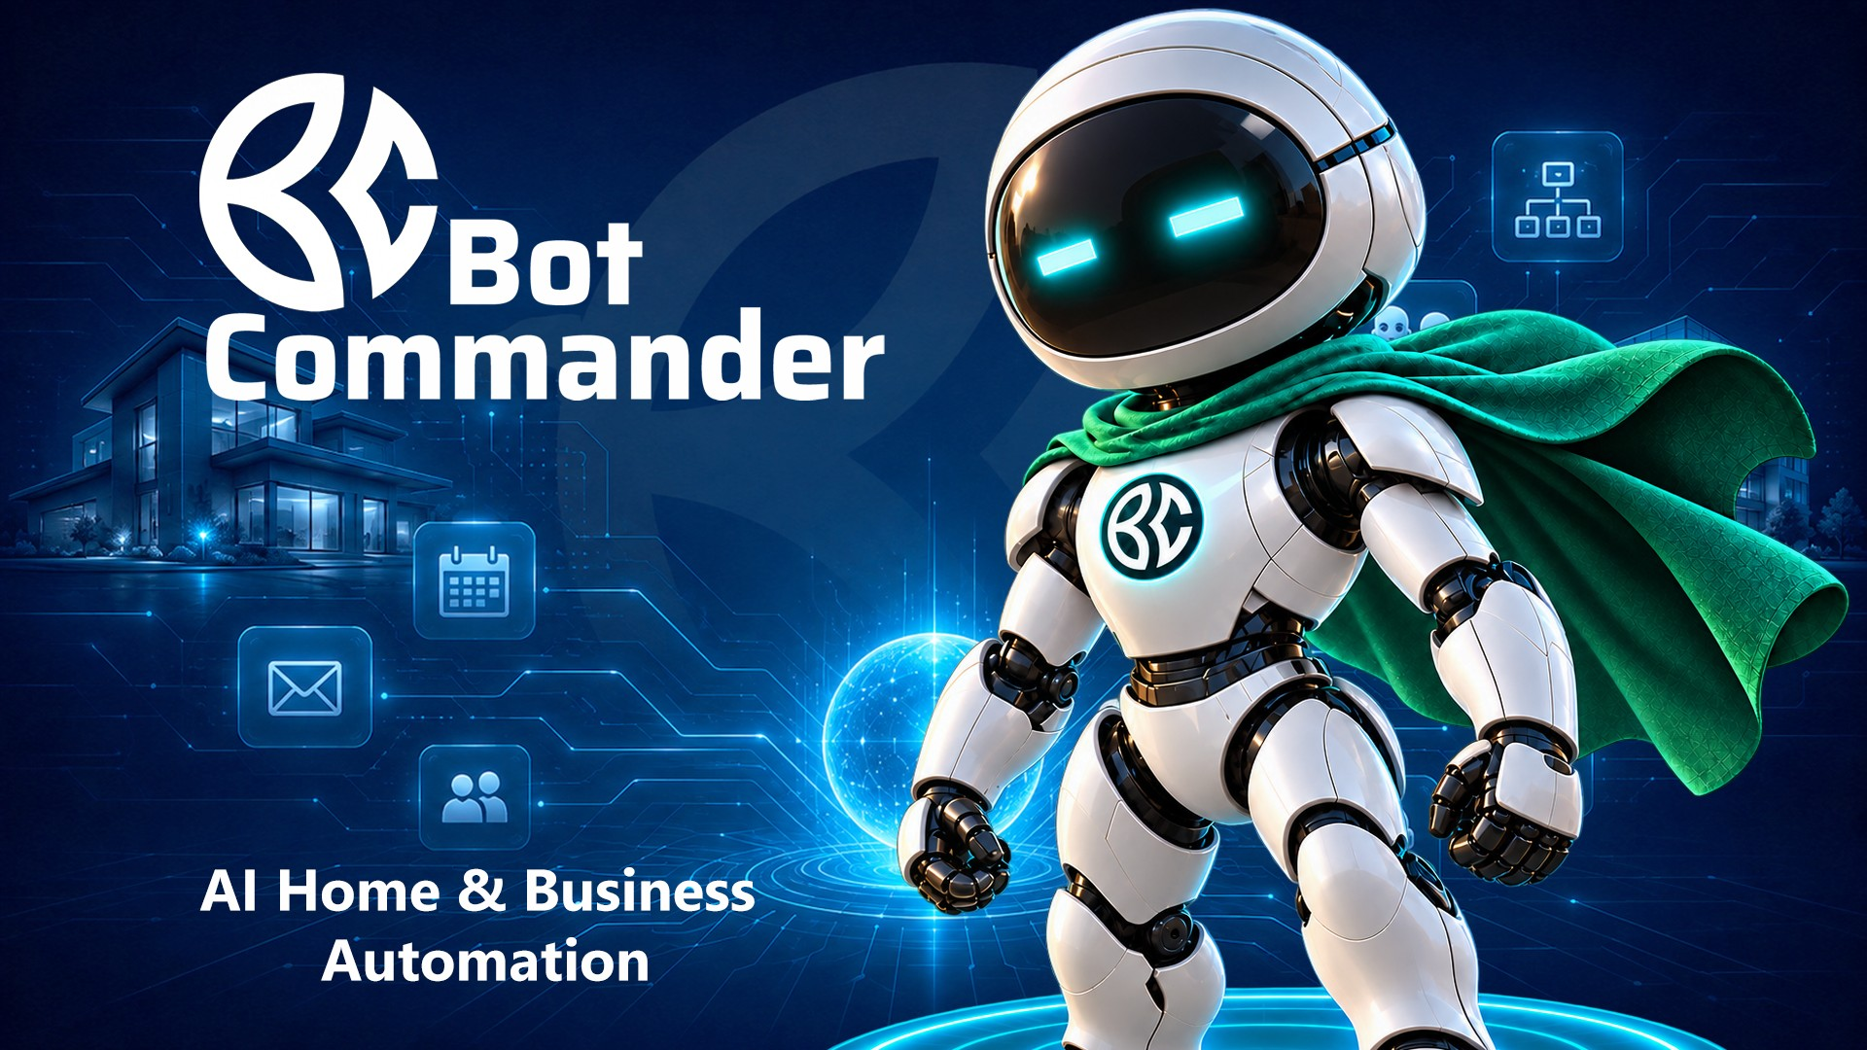
Bot Commander: AI Home & Business Automation. Courtesy of BotCom Inc.
LAKE SHORE, Minn. — Oct. 27, 2026 — BotCom Inc. today introduced Bot Commander version 0.5, its free AI Home & Business Automation System, worldwide. The desktop app replaces the single chatbot with a coordinated team of AI specialists. A user speaks one request in plain English. Their personal AI "Bot Commander" plans the work, assigns it to specialist agents for marketing, sales, finance, scheduling, research, creative production, and website building, and returns the results for approval.
The launch arrives as the world's largest technology companies race to sell AI agents. Most of those agents run in the vendor's cloud, are tied to the vendor's own AI models, and are increasingly sold through monthly subscriptions. Bot Commander takes the opposite approach. The complete app is free and runs on the user's own computer. It works with the user's choice of more than 200 AI model options, including models that can run entirely on compatible local hardware.
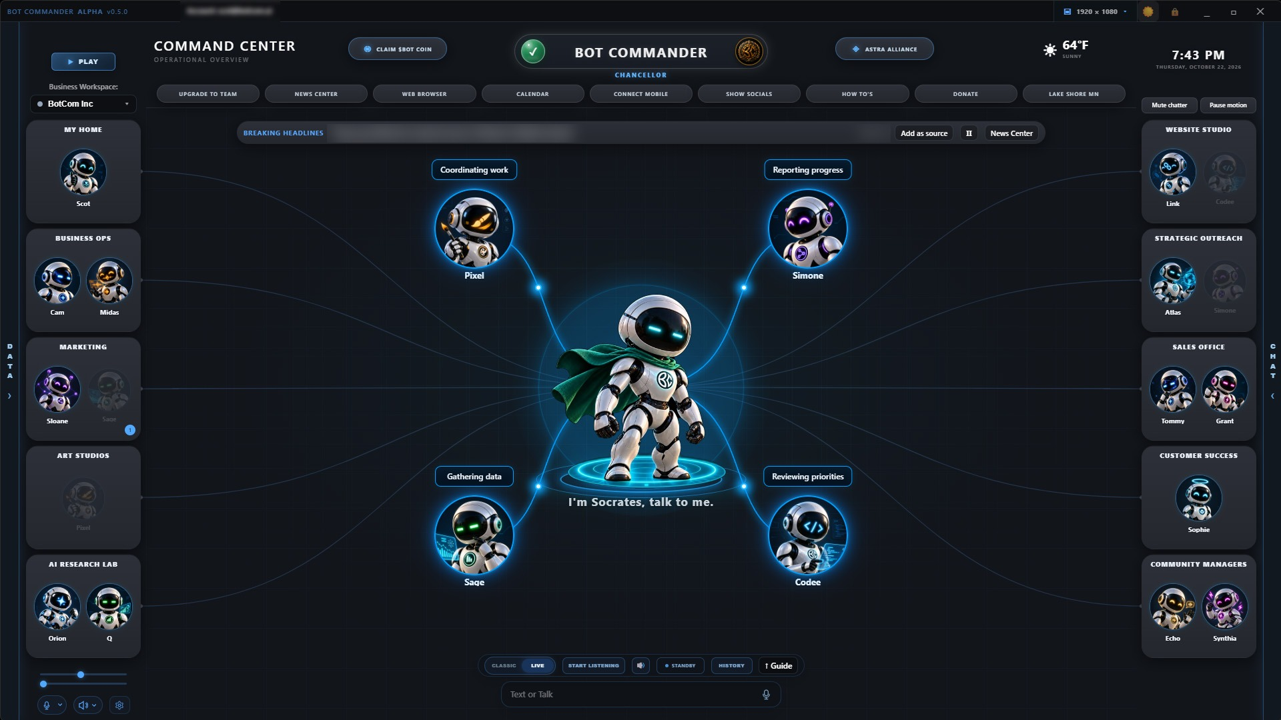
The Bot Commander v0.5 Command Center: your personal AI Commander (here, "Socrates") coordinates specialist agents organized into departments. Courtesy of Bot Commander.
"Every major AI agent on the market works for the company that built it," said Scot Kinney, founder of BotCom Inc. "We built Bot Commander to work for you. You choose the AI. You name your Commander. You decide what your team does and what needs your approval. And you don't pay us a subscription to do it."

One request. A whole team at work.
In a 59-second demonstration at botcom.ai, a user asks for a social media post by voice. Their Commander, Solomon, coordinates a content specialist and a design specialist. The post is written, illustrated, and published only after the user approves it.
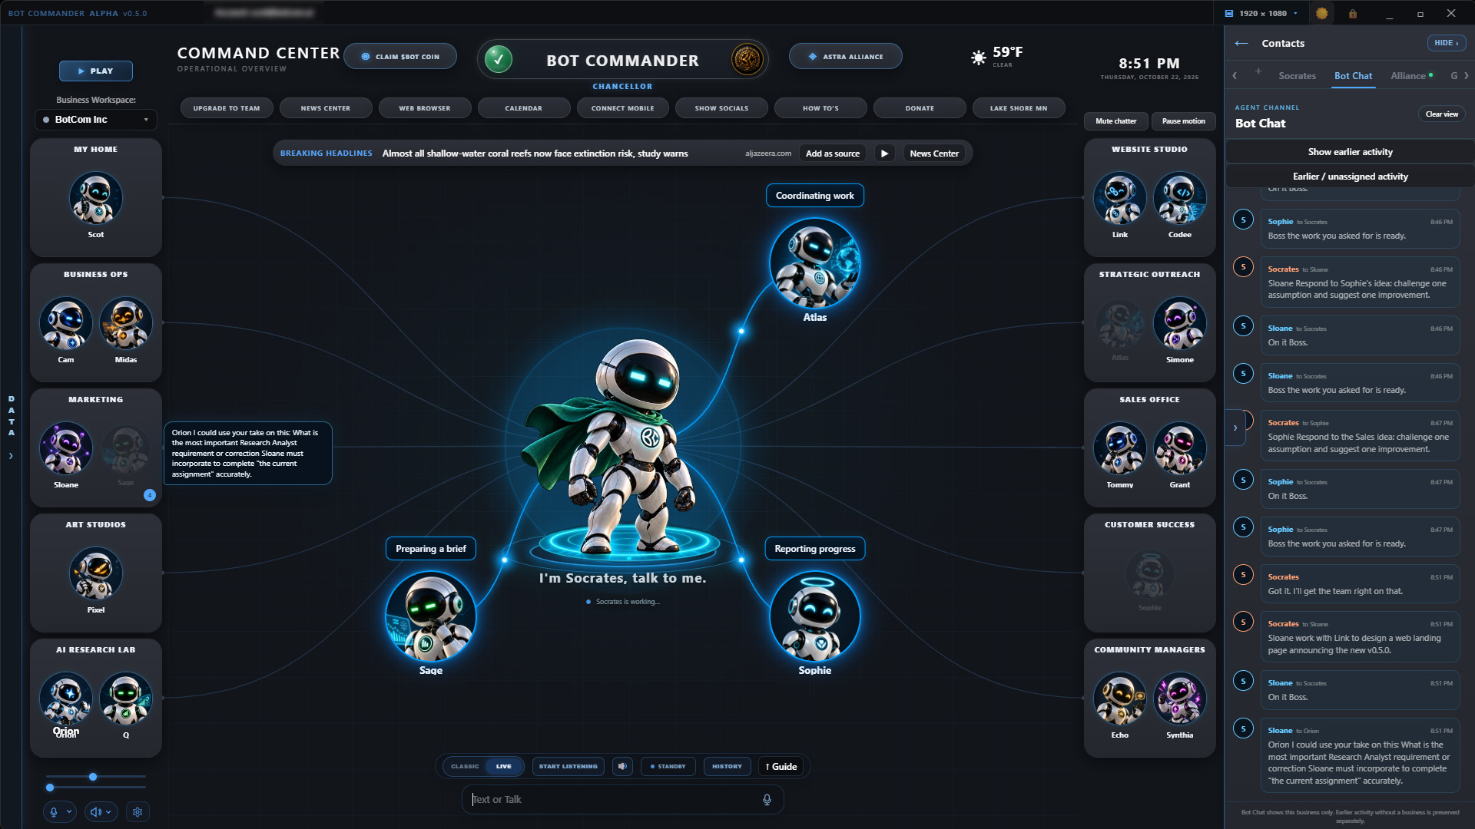
Bot Chat shows the Commander assigning work and agents reporting back, in real time. Courtesy of Bot Commander.
That workflow is the heart of Bot Commander:
- A ready-made AI workforce. Start with 16 preconfigured specialists, then create as many custom agents as needed. Each agent can have its own name, personality, artwork, voice, and AI model.
- Your Commander, your way. Choose from 10 Commander personality presets or build your own, pick a voice, and name your personal AI anything you like.
- Freedom of AI choice. Connect familiar services such as ChatGPT, Claude, Gemini, and Grok. Explore open models like Llama, Qwen, DeepSeek, and NVIDIA Nemotron, or run compatible models locally through Ollama or LM Studio. More than 200 plugins and skill playbooks extend what the team can do.
- Idea to audience. Research, plan, write, design, and produce posts, images, videos, and newsletters, then schedule and publish to supported connected social channels, with approval settings the user controls.
- Work you can see. Live task tracking, automatic progress checklists, mid-task course correction, and full trace logs show what the AI is doing and why.
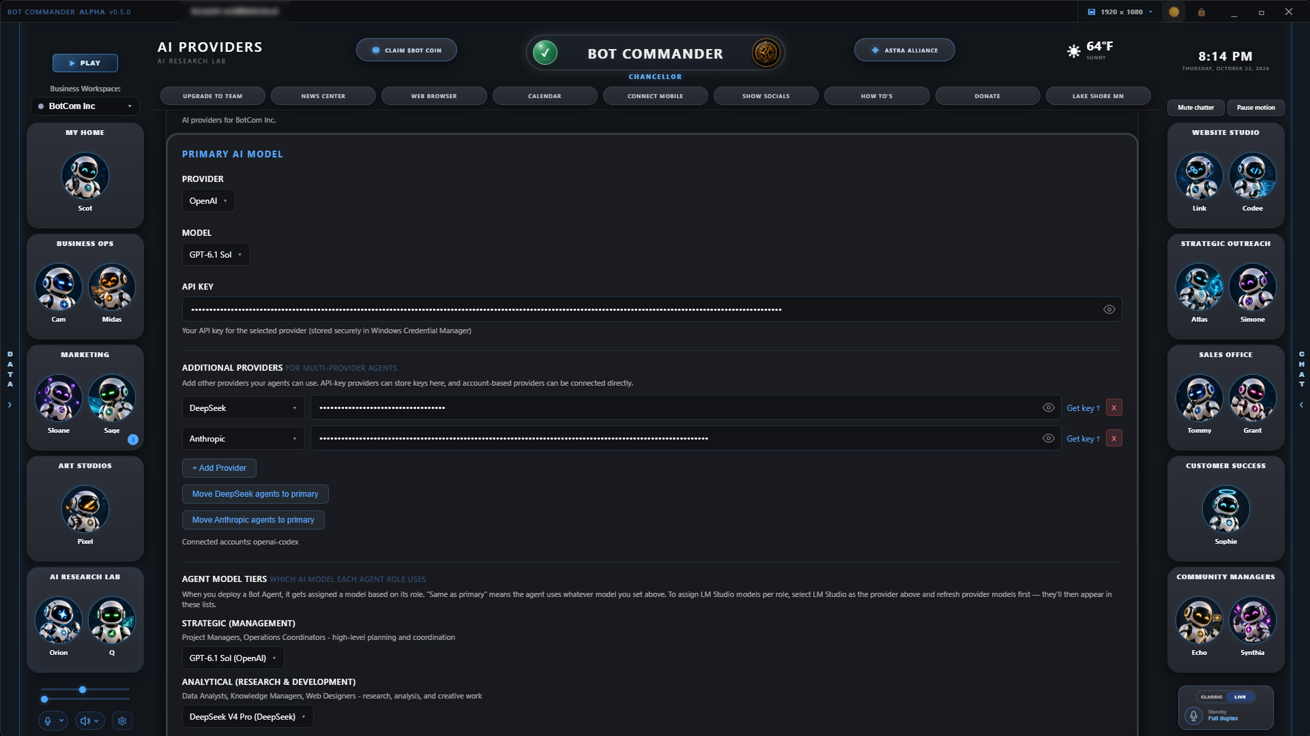
Mix and match AI providers, then assign different models to different agent roles. Courtesy of Bot Commander.

Ready for the desktop AI supercomputer era
A new class of personal AI hardware, including NVIDIA DGX Spark and PCs built on AMD Ryzen AI Max+ processors, puts serious model-running power on the desk. Bot Commander was built for that shift. Because it runs on the user's own computer and connects to local models through Ollama and LM Studio, the same command center that uses cloud AI today can hand work to models running on the user's own hardware. Each agent role can be assigned its own model, so a team can mix local and cloud AI to balance cost, speed, and privacy.
"The future of AI isn't only in someone else's data center," Kinney said. "As powerful AI machines arrive on people's desks, they'll need software that turns all that capability into real work. That's what Bot Commander is for."

Built for the people AI is supposed to help
Bot Commander was designed for the non-technical founder, the solo operator, and the person rethinking their career in an AI-driven economy. No coding is required.
The app's My True Calling journey guides users through five AI-assisted conversations covering their values, strengths, dreams, and real-world resources. It ends with a personal Calling Report and a 30-Day Action Plan. Users who decide a business is their next step can continue into Build Your Business, with their AI team handling the operational heavy lifting.
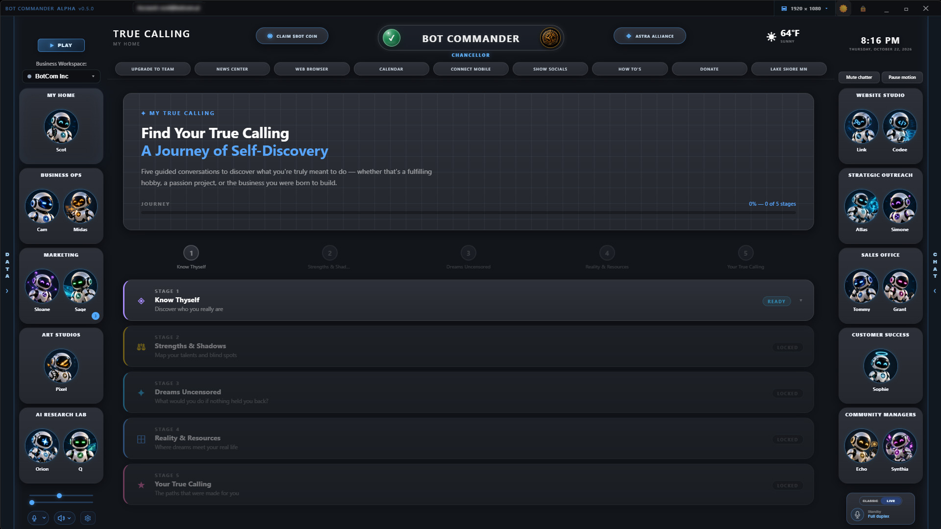
My True Calling: five guided AI conversations that lead to a personal Calling Report and a 30-Day Action Plan. Courtesy of Bot Commander.
"People are being told AI is coming for their jobs," Kinney said. "We think the same technology can be the tool that helps them build something of their own. Bot Commander starts with the person, helping them find their direction, and then gives them a team to pursue it."
Bot Commander also covers the life behind the business. Users get Personal To-Dos, a Grocery List that syncs with their phone, Home Budget, My Health, Friends & Family, Podcasts, and customizable Glass, Dark, and Light workspaces with dozens of backgrounds.

Safety by design, not as an afterthought
As autonomous agents gain access to files, browsers, and accounts, Bot Commander keeps the human in command:
- Two-stage approval for consequential actions. Approving a plan does not authorize irreversible actions. Deletes, sends, and financial transactions require their own explicit confirmation.
- Local-first records. Core desktop records are stored on the user's computer. Cloud AI services and connected tools receive only the information needed for the tasks the user runs.
- Protected credentials. On Windows, API keys are kept in the operating system's encrypted Credential Manager rather than in plain text.
- Signed releases and audit trails. Windows releases are code-signed through Microsoft's signing service, and an append-only log records every AI tool call.
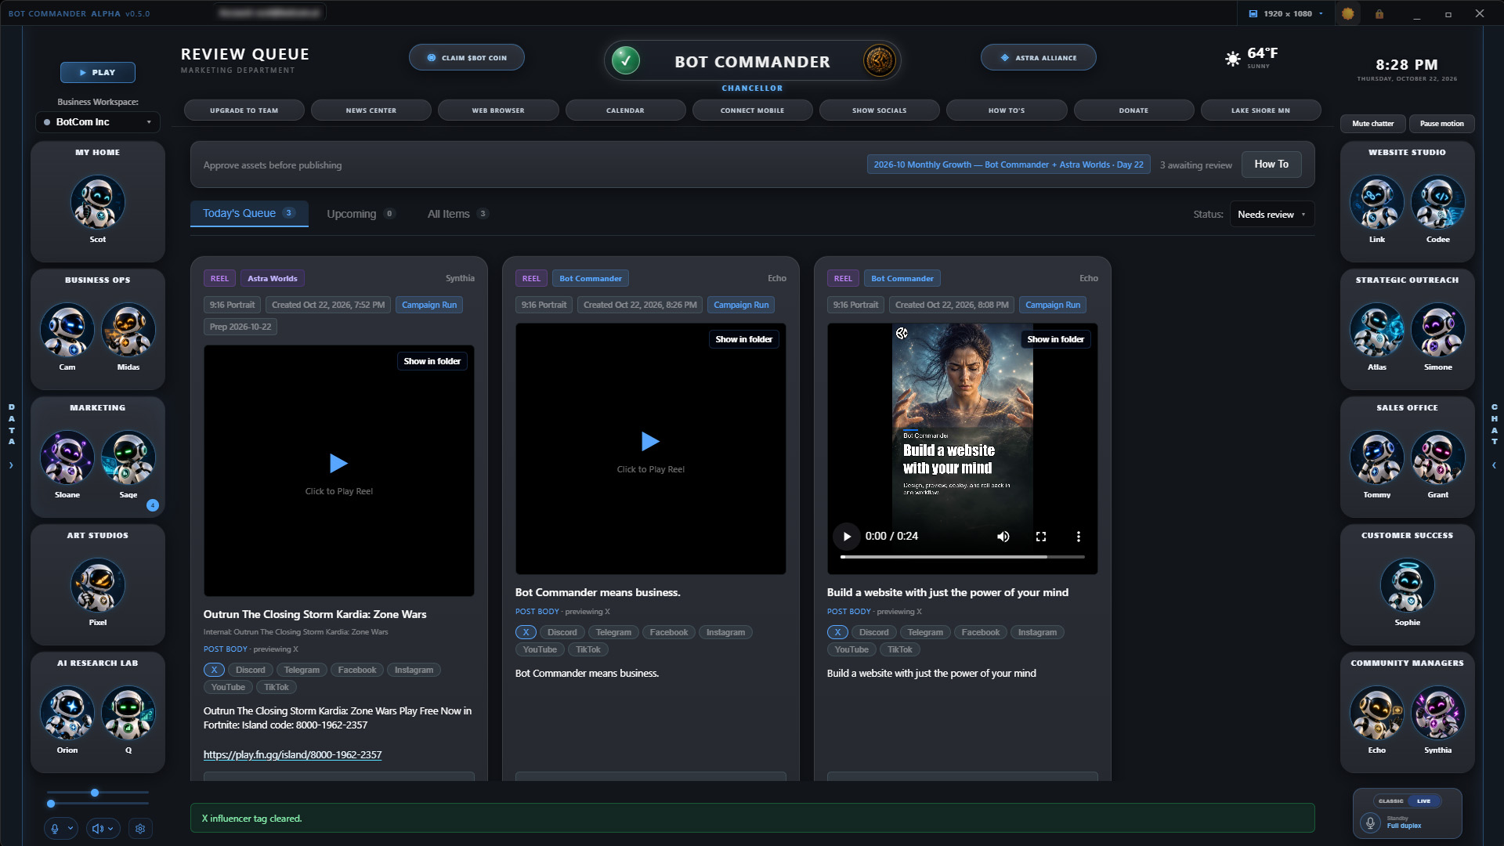
The Review Queue: AI-produced content waits for the user's approval before anything is published. Courtesy of Bot Commander.

Stay connected with The Com
The Com, Bot Commander's free mobile companion, keeps users connected to their command center away from the desk. Users can talk to their Commander, receive reminders and alerts, review decisions waiting on them, and supervise supported desktop work from their phone. The Com also works as a private messaging and calling app for friends, family, and teams. Every Com user receives a permanent six-digit Com# assigned in signup order, so early adopters claim the lowest numbers.
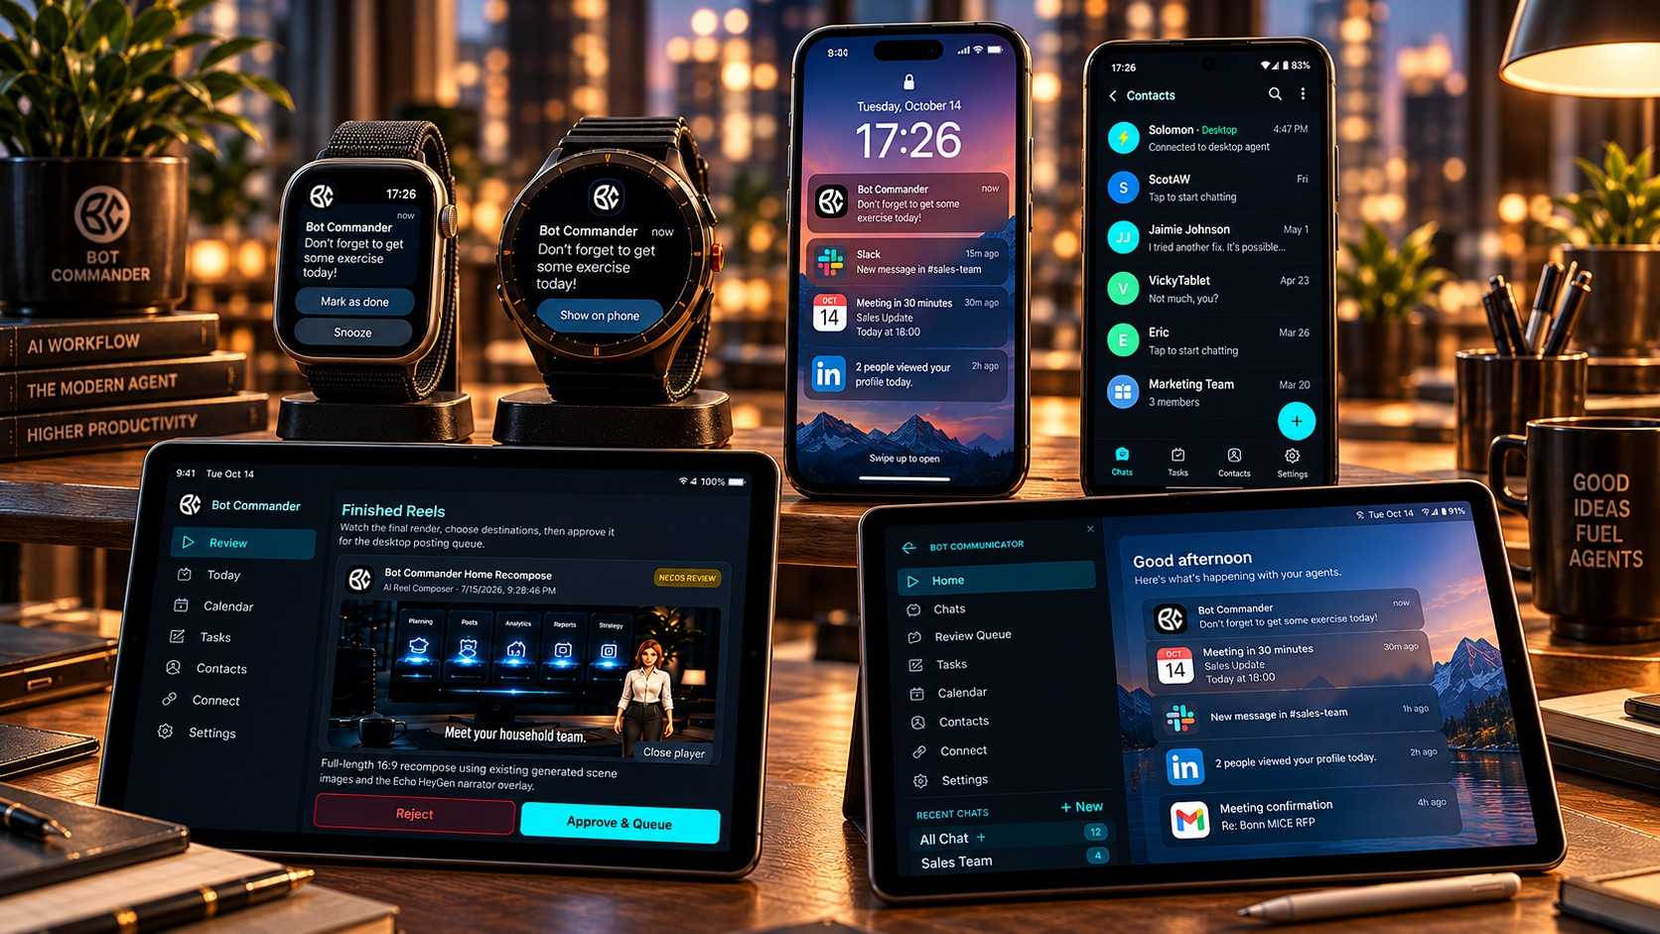
The Com keeps Bot Commander within reach across phone, tablet, and watch (illustration). Courtesy of Bot Commander.

Step into 3D, and into Astra Worlds
Bot Commander isn't only a dashboard. Press Play and the workspace opens into an explorable 3D room. Two rooms are included: the Mountain Lake Executive Office and the Ocean Command Room, both generated with World Labs' Marble world model. Press Work and the full command center returns over the same view.
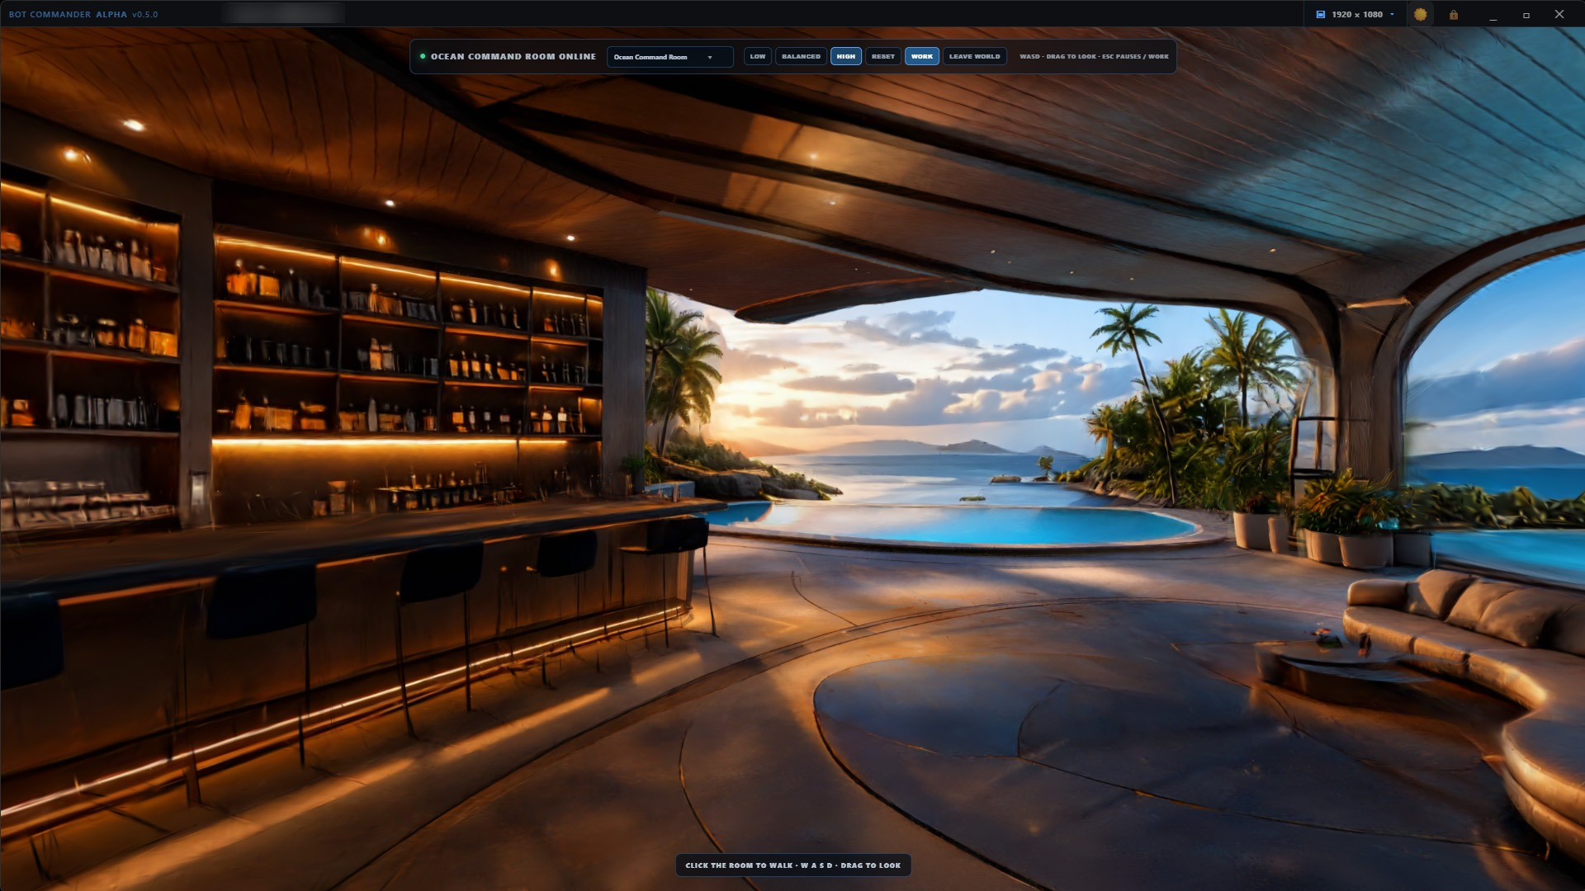
Play mode in Bot Commander v0.5: walk the Ocean Command Room, then switch back to Work in one click. Room generated with World Labs' Marble. Courtesy of Bot Commander.
The rooms are the first step toward bringing Astra Worlds into Bot Commander. Astra Worlds is BotCom Inc.'s game universe, and it's already live on Fortnite: the studio publishes islands in Fortnite Creative under the creator code astraworlds, including Kardia – Zone Wars, Kardia – Get The Gold, Solaris – Team Deathmatch, and Scar City – Bot Commander. The islands are remakes of worlds the team originally built for its earlier AlterVerse project, and the same worlds appear in Bot Commander's built-in workspace backgrounds. Players can jump in today with island code 8135-9126-1165 (Scar City – Bot Commander).
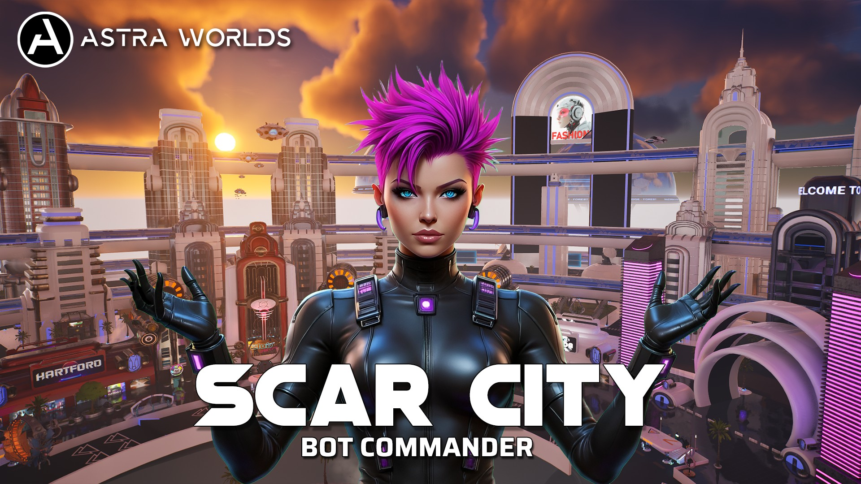
Scar City – Bot Commander, an Astra Worlds island live in Fortnite Creative. Island code 8135-9126-1165. Courtesy of BotCom Inc.
Next, the team is working toward a creator platform inside Bot Commander. Plans include integrating the open-source Babylon.js Editor so users can design their own 3D worlds and interactive experiences with help from their AI team, then share them. A few team-built worlds will show what's possible. Astra Worlds creation tools are in development; timing, hosting, and sharing details will be announced later.

Ready for the agent economy
Bot Commander also connects AI agents to modern payments, with the user in control. Users can set up a Coinbase Developer Platform wallet on Base for USDC transfers and x402 pay-per-use payments. They can also connect a Coinbase Advanced Trade account and work with a dedicated market-intelligence agent. Wallet actions stay behind explicit user confirmation, and user-set trading limits are enforced inside the app before any order reaches Coinbase. The agent cannot override them.

Free for everyone. Value for Value.
The complete Bot Commander desktop app is free, with no credit card required. Users connect the AI providers and services they choose, and those providers may charge their own usage fees. Bot Commander follows a Value-for-Value model: people who find the app valuable are invited, never required, to give back through their Time, Talent, or Treasure. They receive permanent recognition in the Astra Alliance community.
For businesses ready to bring in their people, the optional Bot Commander Team Version adds a shared business workspace and individual role-based access through a separately configured business server. For launch, Team Version is free for the first 100 businesses that use code bongino at checkout.

Availability
Bot Commander v0.5 is available now as a free download for Windows, macOS, and Linux at https://botcom.ai/download.html. The Com mobile companion is available on iOS through the App Store and on Android as a direct APK download.
Watch the demo and follow the launch:
- Website: https://botcom.ai
- YouTube: https://www.youtube.com/@botcomai
- X: https://x.com/botcomai
- Astra Worlds: https://astraworlds.com

About BotCom Inc.
BotCom Inc. builds Bot Commander, a free, local-first AI Home & Business Automation System for Windows, macOS, and Linux, and Astra Worlds, a game universe with islands live on Fortnite. Bot Commander lets anyone direct a team of specialized AI agents by voice across marketing, CRM, accounting, scheduling, research, content creation, website building, and everyday personal organization. It works with the user's choice of AI providers and open models, including models running locally on the user's own hardware, and includes explorable 3D rooms that preview the company's Astra Worlds creator vision. Its mission is to put the power of AI into the hands of everyday people, helping them build their businesses, organize their lives, and reclaim time for what matters most. Learn more at https://botcom.ai.

Media Contact
Scot Kinney
BotCom Inc.
info@botcom.ai
Press kit, screenshots, and demo video: https://botcom.ai/press.html
Full press-kit ZIP: https://botcom.ai/press/Bot-Commander-Press-Kit-20261023.zip
###
Bot Commander is free to download and use. AI provider usage, connected services, hosting, and optional upgrades such as Team Version may carry their own costs and setup requirements. Available models and channels depend on the user's accounts, hardware, and configuration. Local model performance depends on the model and hardware. Bot Commander is not affiliated with or endorsed by NVIDIA, AMD, Coinbase, World Labs, or Epic Games. Fortnite is a trademark of Epic Games, Inc. Cryptocurrency and trading features involve financial risk and are not investment advice. Astra Worlds creation features are forward-looking and subject to change. Product names mentioned are trademarks of their respective owners.

